As Crepuscule Closes In

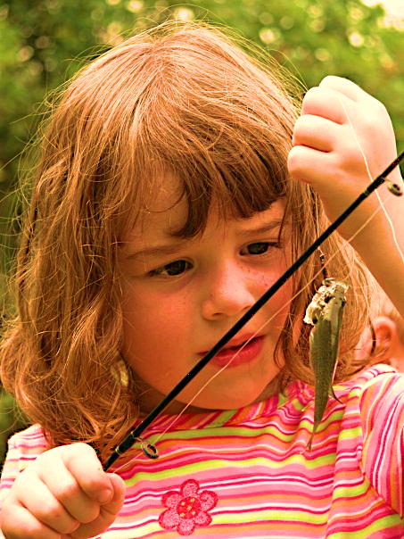
A faint zephyr curled the tip of her hair. Shoulder length. The lapping of edge water murmuring. Inveigling liquid whispers heralding dusk – some primal tongue understood by the ancients – as myriad golden shines danced atop aquatic undulations. Leaves began singing the dirge of the descending day. Framed in Spanish moss, a vermillion skyline yawning. Harbinger soon some phase of moon, amphibious crooning abounds. A hand-sized perch in her fist.

Aeonian nature’s colloquy. Conference of wind and fire and rain and earth knowing no end. A mere breath a contribution. Even as one life wiggles away, she sees. Matrimony of time and space – horizon ever-bound – in Lasting Overtures Vastly Evolving.

She holds the handle, blank to the sky, guides giving line ascent. Tip. Fall—with angular ease.

Her eyes gaze up to me. Curious, dilated, free. A parting of the lips, a palm on the hips:

“Dahhy, juss whon mohr casss—Pwease?”

